Google’s Stock Price Prediction Using LSTM

School of Computer Science Engineering and Technology


Bennett University
Greater Noida, Uttar Pradesh

Submitted by: Submitted to: Dr. Uphar Singh
Yash Jain, E22CSEU0394
Kumkum Singh, E22CSEU0395
Utsav, E22CSEU0396

I. Introduction
1) Objective

The aim of this project is to create a time series forecasting model that predicts future stock prices of Google (GOOGL) through the application of deep learning methodologies. This initiative utilizes historical stock data along with technical indicators to train an LSTM (Long Short-Term Memory) model, which is capable of effectively identifying temporal dependencies and trends within the dataset.

2) Research Question
Are LSTM-based models capable of effectively identifying historical trends in Google's stock prices to produce precise short-term price predictions, surpassing conventional techniques such as moving averages?
3) Problem Statement
Forecasting stock prices presents significant challenges owing to the unpredictable characteristics of the financial market, which is influenced by both technical elements and external factors. Conventional statistical models frequently struggle to capture long-term dependencies and nonlinear trends. This project seeks to overcome these difficulties by utilizing LSTM networks—a specific kind of recurrent neural network that is adept at preserving long-term information—on historical Google stock data, with the goal of enhancing the precision of time series predictions.

II. Data Collection & Preprocessing
1) Dataset Description
- Source-
- Yahoo Finance: Daily historical data for GOOGL using the ‘yfinance’ APL.
- Dataset Duration: June 14, 2016 – September 21, 2024
- Total Records: 2,082 rows
- No missing or duplicated data
Variable | Description
Open | Stock's opening price on a given day
High | Highest price of the stock during the trading session
Low | Lowest price of the stock during the session
Close | Price at which the stock closed that day
Volume | Total number of shares traded on that day
Dividends | Cash distributions to shareholders
Stock Splits | Stock division events for affordability and liquidity

III. Time Series Modelling & Diagnostics
- Trend Visualization: Line graphs depicting 'Close' prices indicate a long-term upward trend with variations.
- Candlestick Charts: Employed to illustrate daily trading behaviours.
- Technical Indicators Incorporated: SMA (Simple Moving Averages): 10, 20, and 50-day. The 10-day and 20-day SMAs closely track the original data, enhancing trend alignment.
- Volume Analysis: Utilized for evaluating volatility.
- Normalization: Implemented MinMaxScaler to adjust all values within the range of 0 to 1 for model training.
A Time Series Modelling Methodology
- Attributes of Time Series Data Time series data exhibits temporal dependencies and patterns over time (such as trends and cycles), which are crucial for predicting future stock prices based on historical values.
- The Rationale for Using LSTM and RNN RNNs are specifically engineered to handle sequences by retaining short-term memory, yet they face challenges with vanishing gradients.
- LSTM, an advanced form of RNN, is capable of capturing long-term dependencies and addressing the limitations of RNNs, thus making it well-suited for stock market predictions.
Data Preparation for LSTM Modelling
- Sequence Generation Utilized a sliding window technique: each sequence is composed of stock prices from the preceding 10 days to forecast the price for the subsequent day
- Data Division Training Set: 80%, Validation Set: 10%, Test Set: 10%
LSTM Model Implementation
- TensorFlow-Based Modelling
- Architecture:
  - Input Layer: 10-day sequences
  - 2 LSTM Layers (with dropout)
  - Dense Output Layer (1 neuron for next-day prediction)
- Loss Function: Mean Squared Error (MSE)
- Optimizer: Adam
- Epochs: 100+ with early stopping
- Batch Size: 32
- PyTorch-Based Modelling
- Built similar LSTM architecture using nn.LSTM, nn.Linear, and nn.MSELoss
- Used GPU acceleration if available
- Trained with Adam optimizer and backpropagation through time

IV. Visual Evaluation
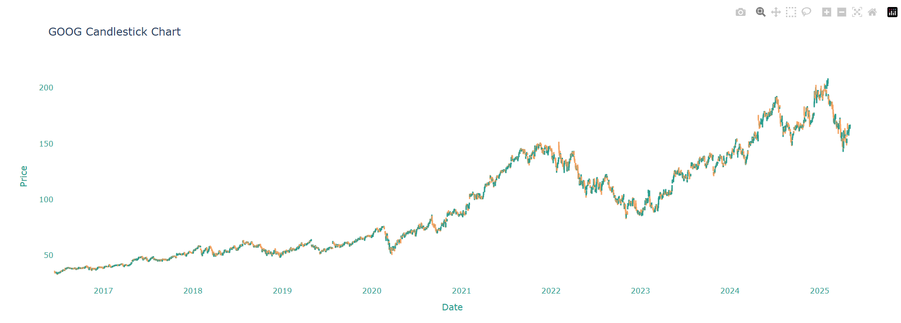
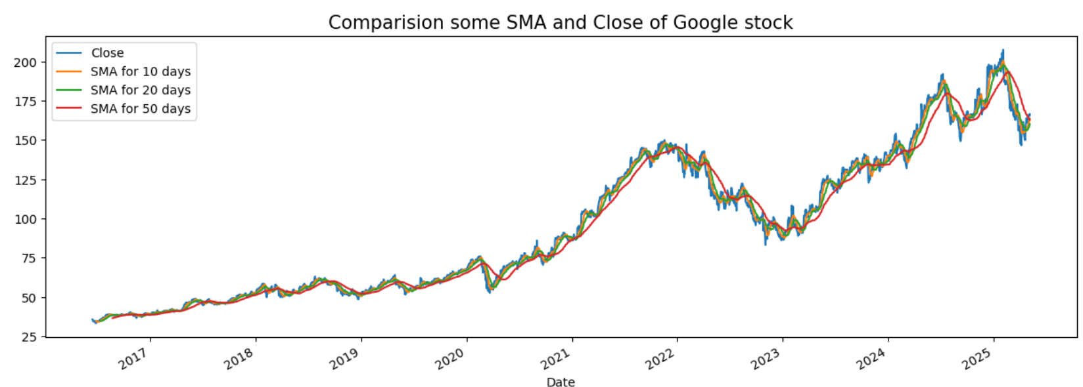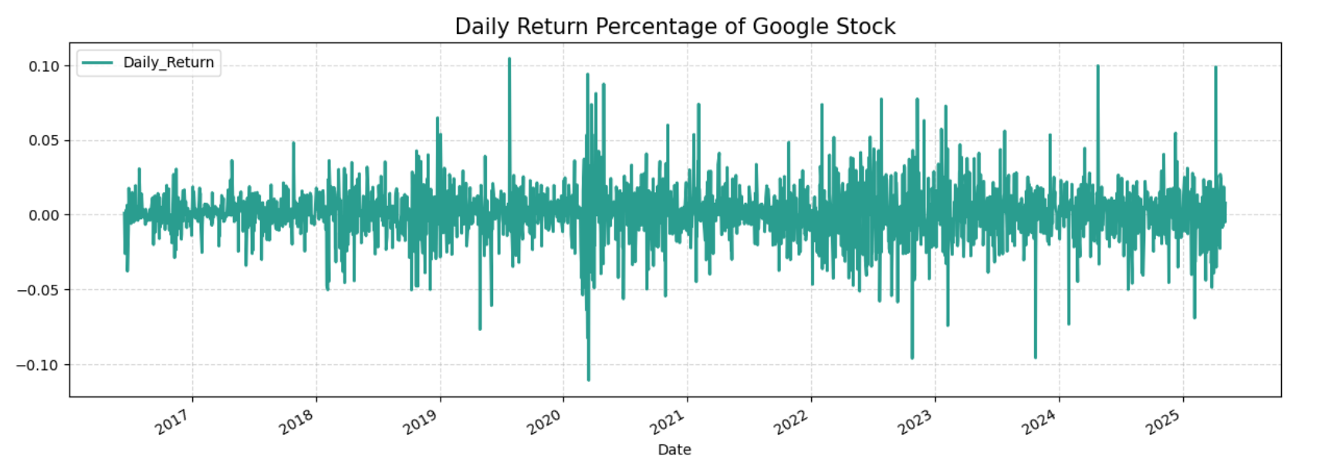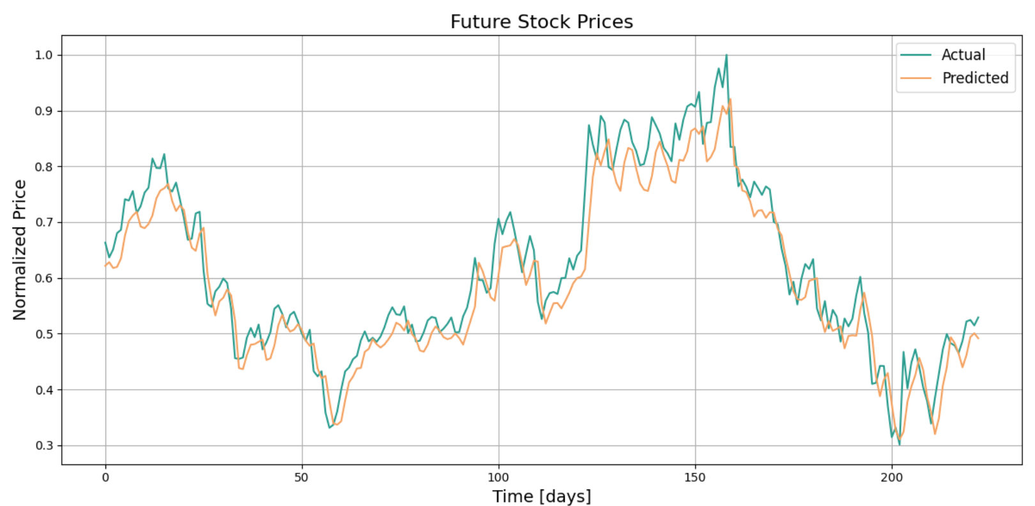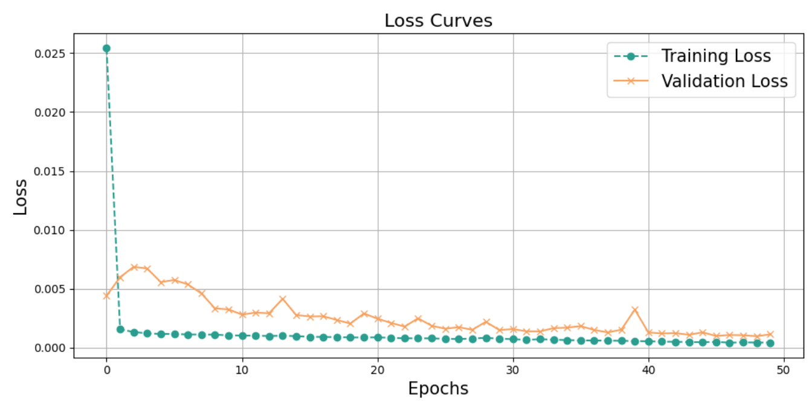
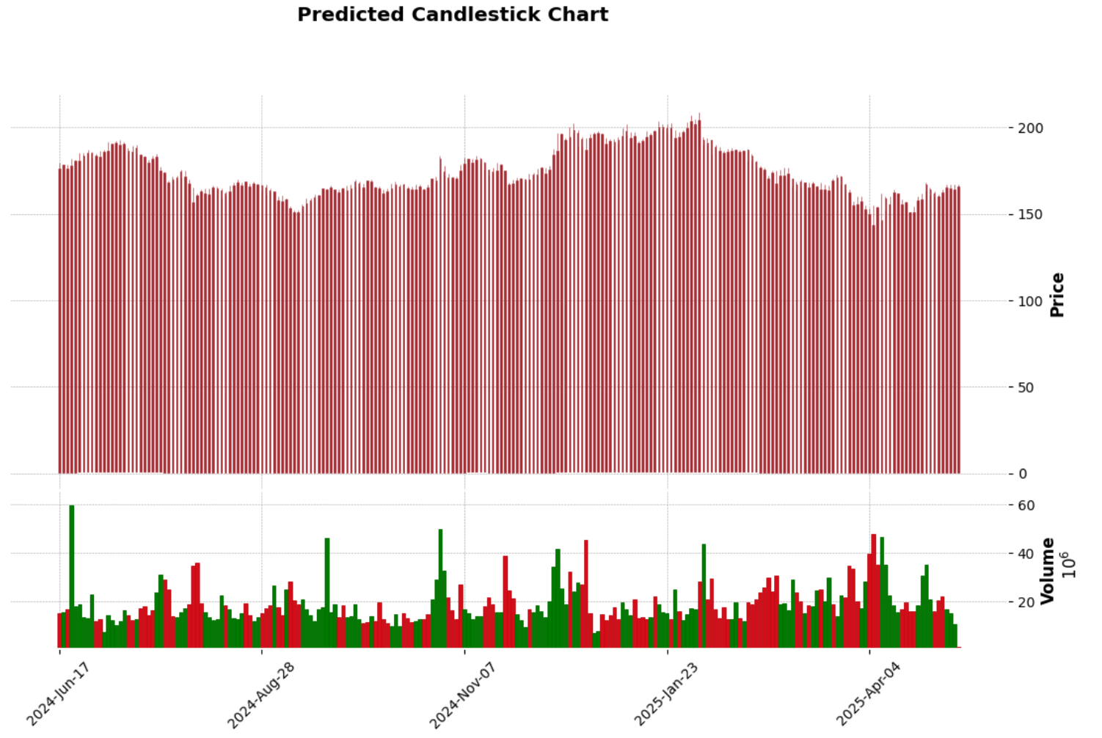

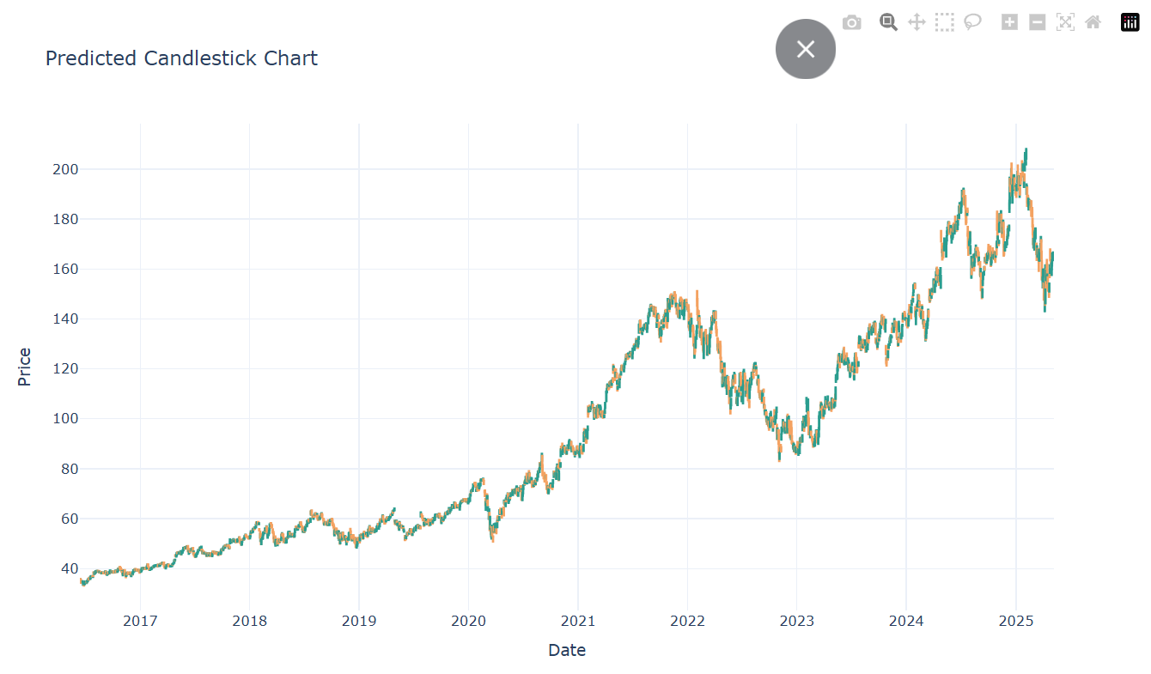

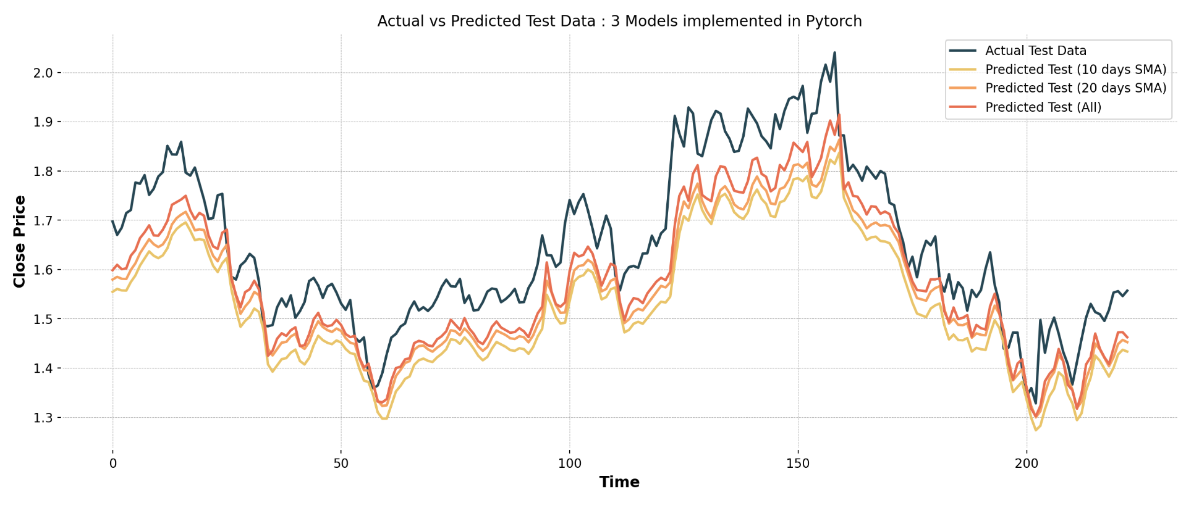

Note: More visuals are present in Colab file attached below.
V. Discussion and Conclusion
Key Insights:
- LSTM successfully identifies sequential relationships and temporal patterns in Google stock prices.
- The implementation of 10- and 20-day Simple Moving Averages (SMAs) greatly improves the quality of signals.
- Both TensorFlow and PyTorch LSTM models achieved high levels of accuracy and generalizability.
- The absence of significant seasonality further validates the selection of the model.

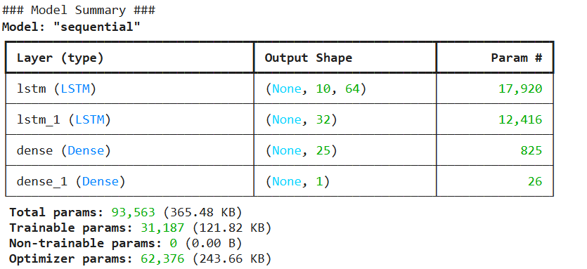

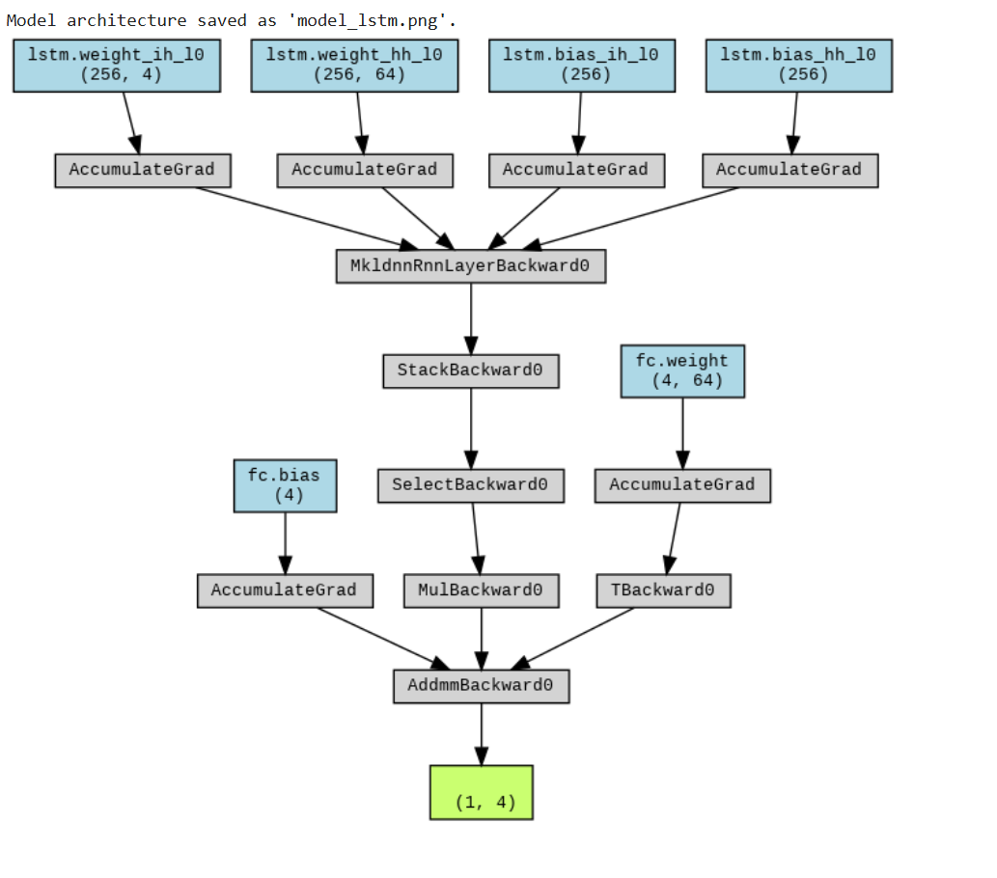
Model limitations:
- It does not account for sentiment data, macroeconomic factors, or real-time news that could affect stock prices.
- Additionally, it is restricted to univariate predictions, focusing solely on closing prices, whereas multivariate modelling could enhance accuracy.

VI. Future Work
- Incorporating news sentiment (e.g., via NLP from Google News)
- Including macroeconomic variables like interest rates, inflation
- Using attention-based models (e.g., Transformer, Temporal Fusion Transformer)
- Implementing hybrid architectures like CNN + LSTM for deeper feature extraction

COLAB FILE LINK:
https://colab.research.google.com/drive/1rmF1qq7sLpuJQrvoXPYB5JmGx_QgVJ8Z?usp=sharing
GITHUB LINK
https://github.com/iyashh/Time_Series.git

